**MISSING FEATURES**

The eCommerce website's testing revealed significant gaps in key elements that need to be addressed to improve user experience and streamline administrative procedures. Addressing these gaps is crucial to meet evolving needs of administrators, consumers, and industry standards.

The following are some of the missing features found in the project under test:

1. Purchasing History for Admin
2. Browsing History
3. Blogs/ News Page for Customer
4. Customer’s order history page (order again)
5. Sales Tracking for Admin (graphs/charts)
6. Management Page for Admin to view or manage Customers
7. Order Inventory for Admin
8. Settings (pay/shipping)
9. Deals & Discounts / Promotions / Sale / Newly added Items
10. Currency Support
11. Multi Language Support
12. Multiple Departments, multiple and different screens for each department
13. Gift Cards
14. Careers
15. Become a seller, multiple screens next ahead
16. Add Reviews about products

**Purchasing History for Admin:**

Purchasing history for admin in eCommerce website is missing. Admins lack visibility into past transactions, hindering their ability to analyze and manage orders effectively. Following is Amazon’s Purchasing history for admin.

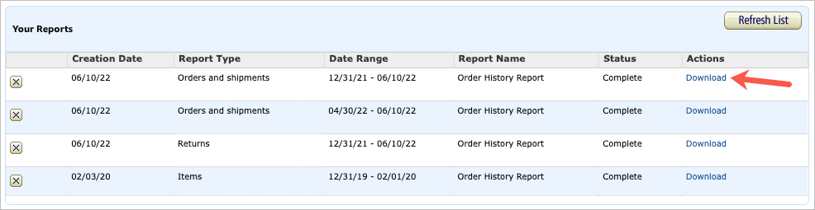

**Browsing History:**

Browsing history for eCommerce website is missing. Without browsing history, users may struggle to recall or locate items they have previously explored. Following is Amazon’s Browsing history page.

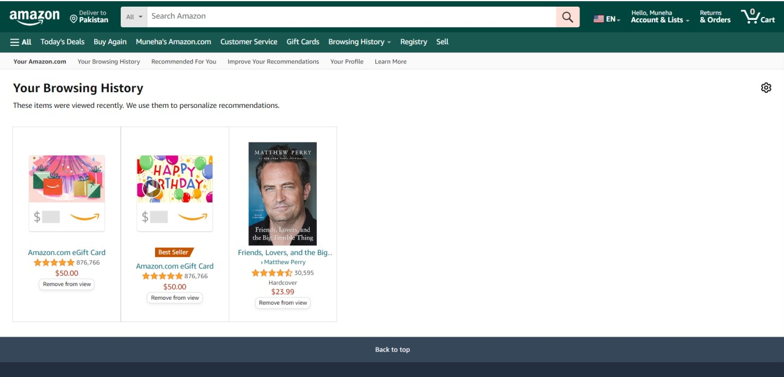

**Blogs/ News Page for Customer:**

Blog/news page for eCommerce website is missing. Users miss out on valuable content, and the application lacks a channel for communication and community building. Following is Amazon’s Blog/news page.

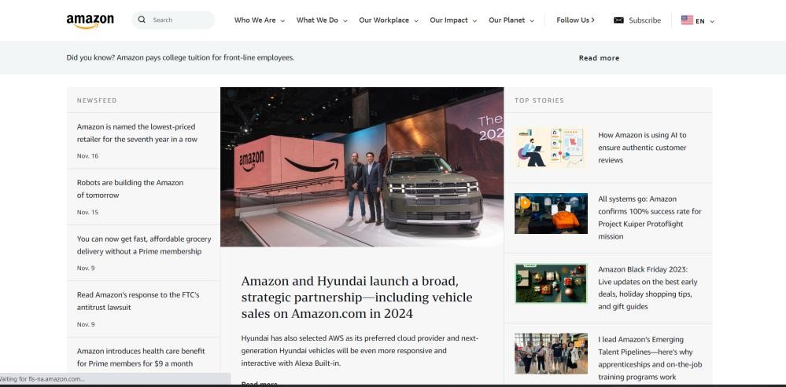

**Customer’s order history page (order again):**

Order history page for eCommerce website is missing. Without an order history page, users cannot easily replicate past orders, leading to a less efficient shopping experience. Following is Amazon’s Order history page.

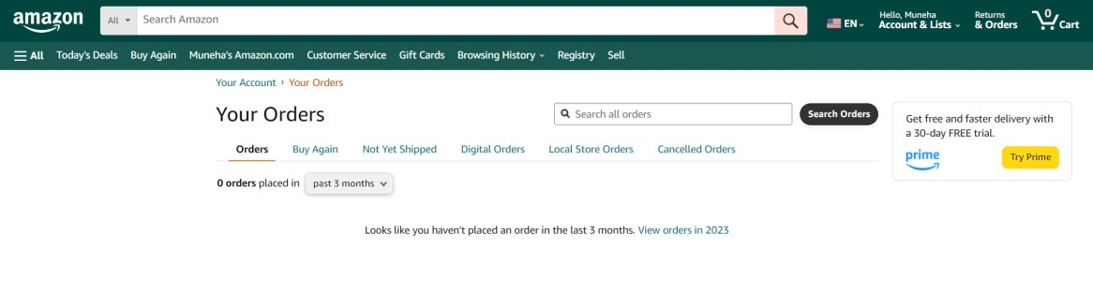

**Sales Tracking for Admin (graphs/charts):**

Sales tracking in eCommerce website is missing. Admins lack the tools to analyze sales data visually, potentially missing opportunities for optimization. Following is Amazon’s Sales tracking page.

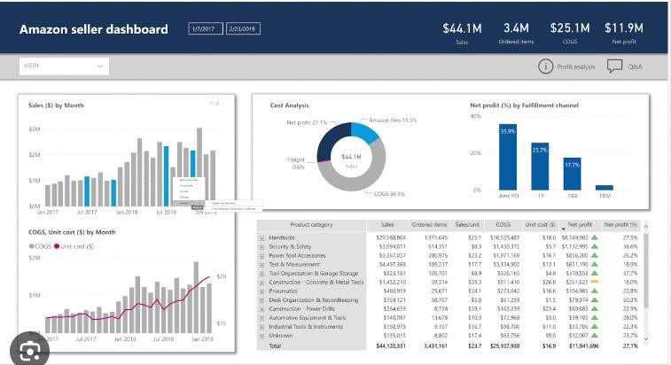

**Management Page for Admin to view or manage Customers:**

Management page for admin in eCommerce website is missing. Admins may struggle to perform necessary customer management tasks, leading to operational inefficiencies. Following is Amazon’s Management page.

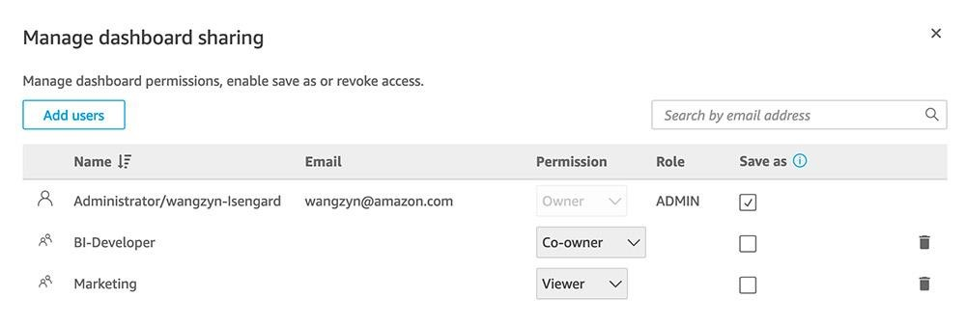

**Order Inventory for Admin:**

Order inventory for admin in eCommerce website is missing. Lack of order inventory tools may result in stockouts or overstock situations, impacting overall business operations. Following is Amazon’s Order inventory.

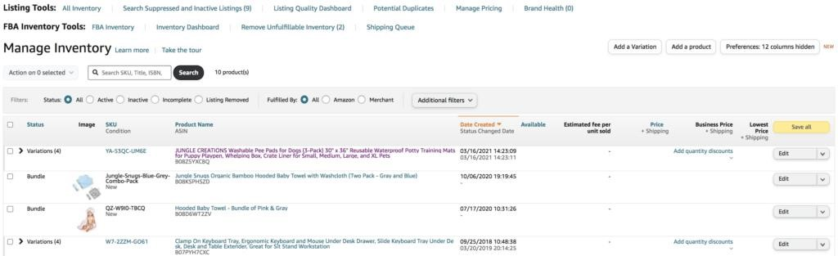

**Settings (pay/shipping):**

Settings option for eCommerce website is missing. Users may find it challenging to tailor the application to their preferences without access to settings. Following is Amazon’s Settings option.

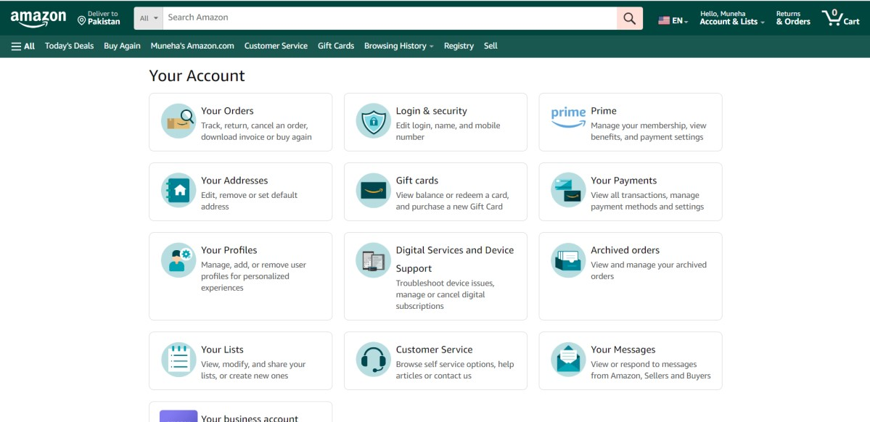

**Deals & Discounts / Promotions / Sale / Newly added Items:**

Deals and discounts page for eCommerce website is missing. Without promotional features, the application may struggle to compete and retain customer interest. Following is Amazon’s Deals and discounts page.

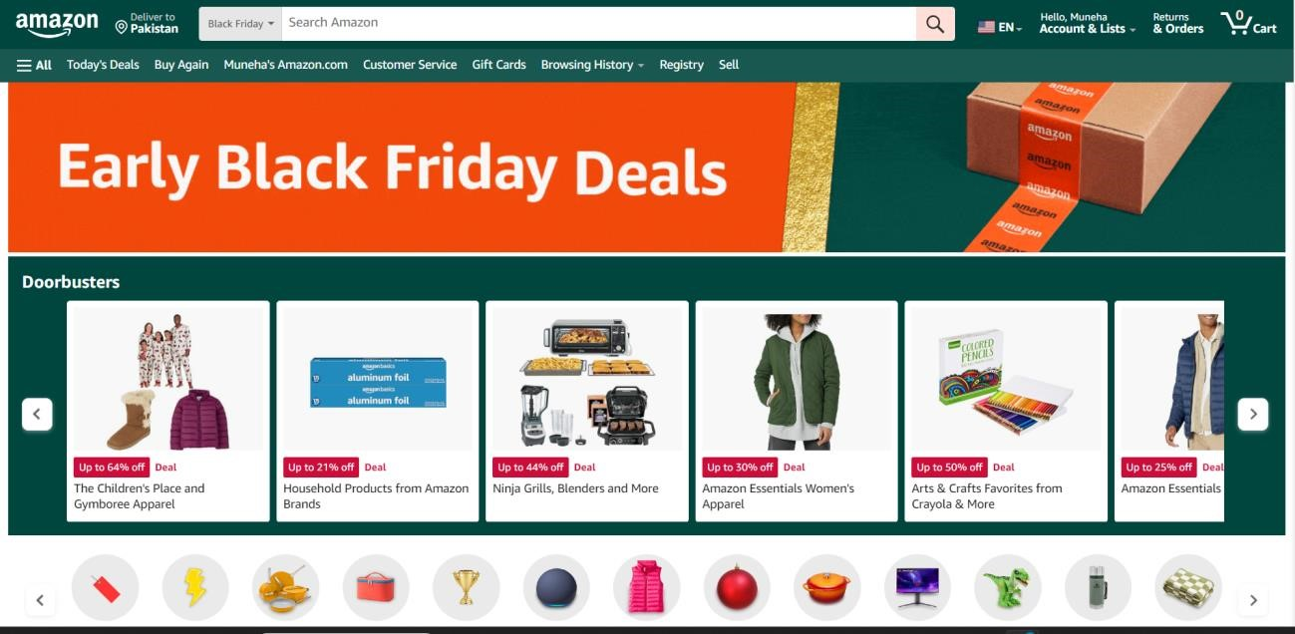

**Currency Support and Multi Language Support:**

Currency support and multi-language option on eCommerce website is missing. Users with other languages and currency may feel excluded, limiting its market reach. Following is Amazon’s Currency support and multi-language options.

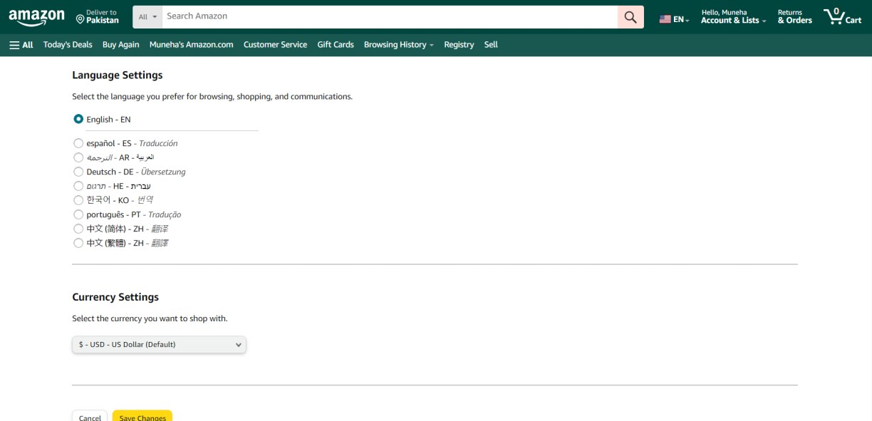

**Multiple Departments, multiple and different screens for each department:**

Multiple departments option for eCommerce website is missing. Without departmental organization, users may face difficulty finding relevant information within the application. Following is Amazon’s Multiple departments option.

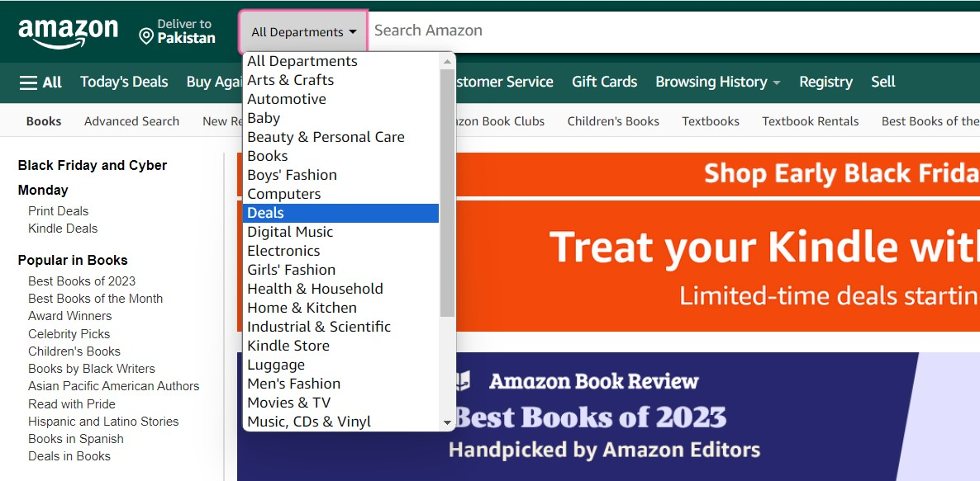

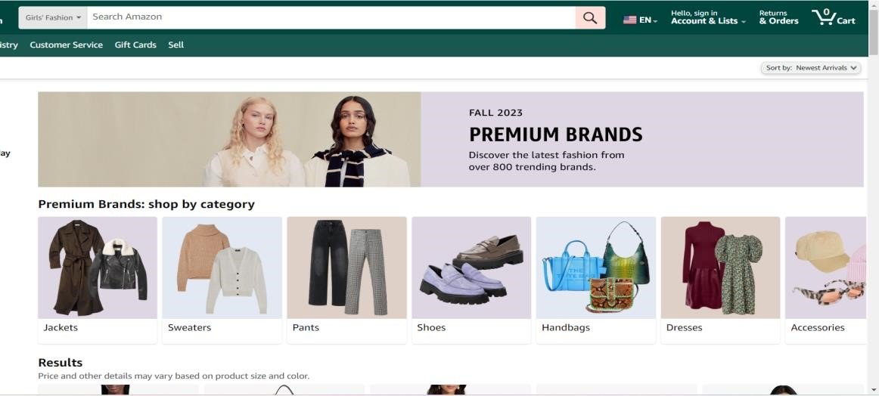

**Gift Cards:**

Gift cards option for eCommerce website is missing. This feature will engage more users. Following is Amazon’s Gift cards option.

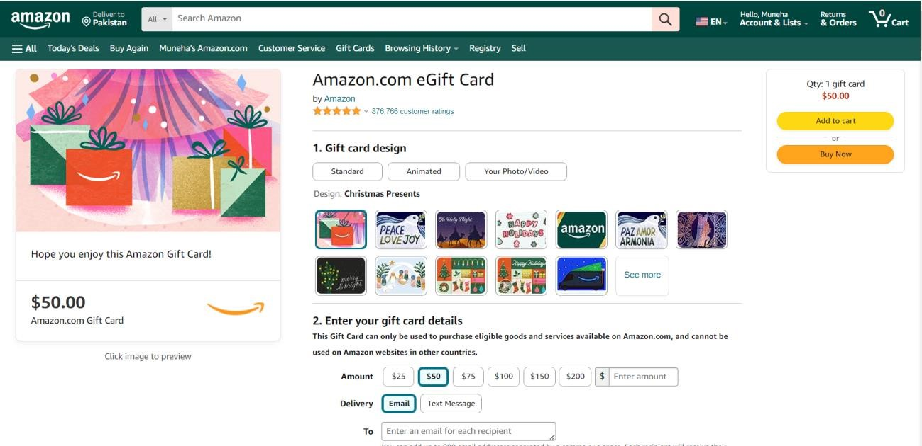

**Careers:**

Careers option for eCommerce website is missing. The absence of a careers section can result in a lack of visibility for job openings. Following is Amazon’s Careers page.

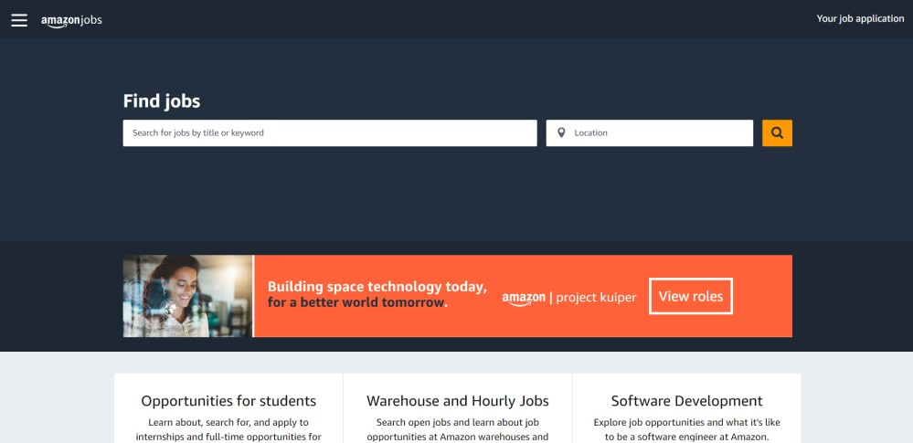

**Become a seller, multiple screens next ahead:**

Seller option for eCommerce website is missing. Such an option will help sellers to have a platform. Following is Amazon’s seller option.

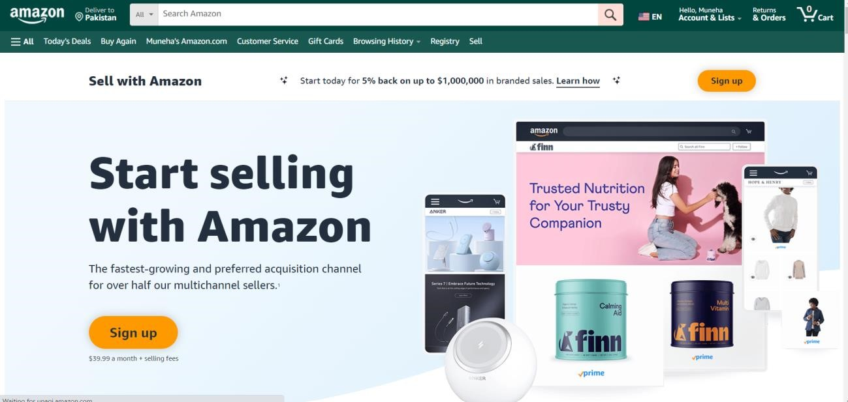

**Add Reviews about products:**

Adding review option on eCommerce website is missing. Without the ability to add reviews, potential buyers may lack information about the quality of product. Following is Amazon’s review page.

